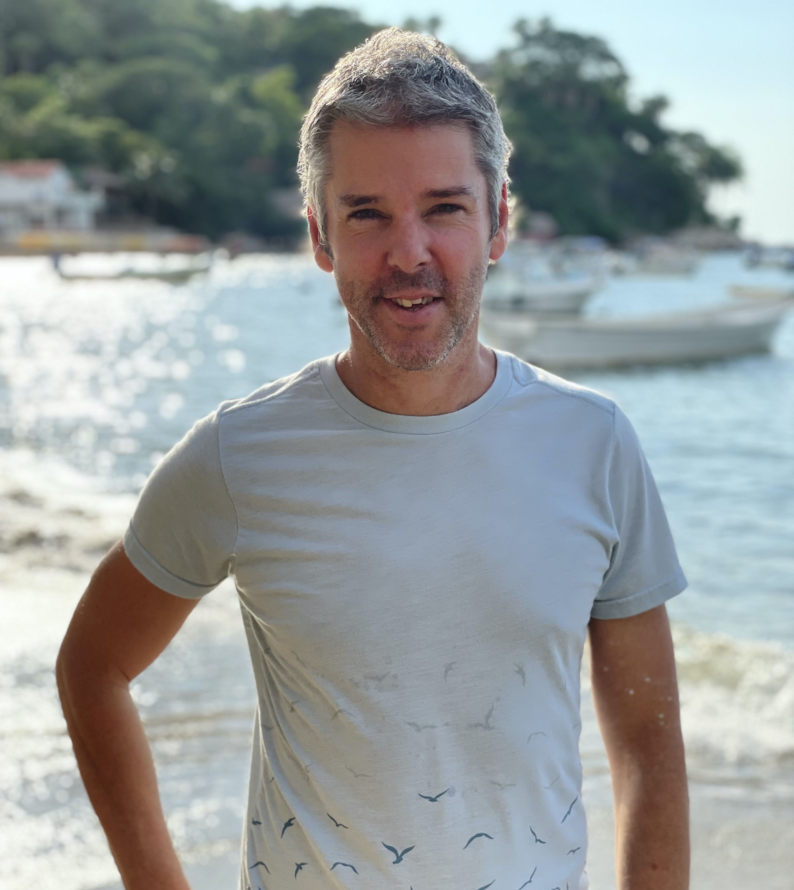
AUTHOR BIO:

MARK T. RASMUSSEN is an Australian Author born by the sea, cultivated in the city, formed via the world. Previously a professional journalist and editor, these days Mark writes evocative, thought provoking subject matter for his adult novels and screenplays, along with fun, captivating and thoughtful books for children. When Mark isn’t writing, he splits his time between reading and the fabulousness of fatherhood. An avid adventurer, having travelled 55+ countries across six continents, he currently lives in a remote Mexican seaside-jungle village with his beautiful and brilliant, author wife, and youngest son, finding it an idyllic piece of paradise to read, write, and love.
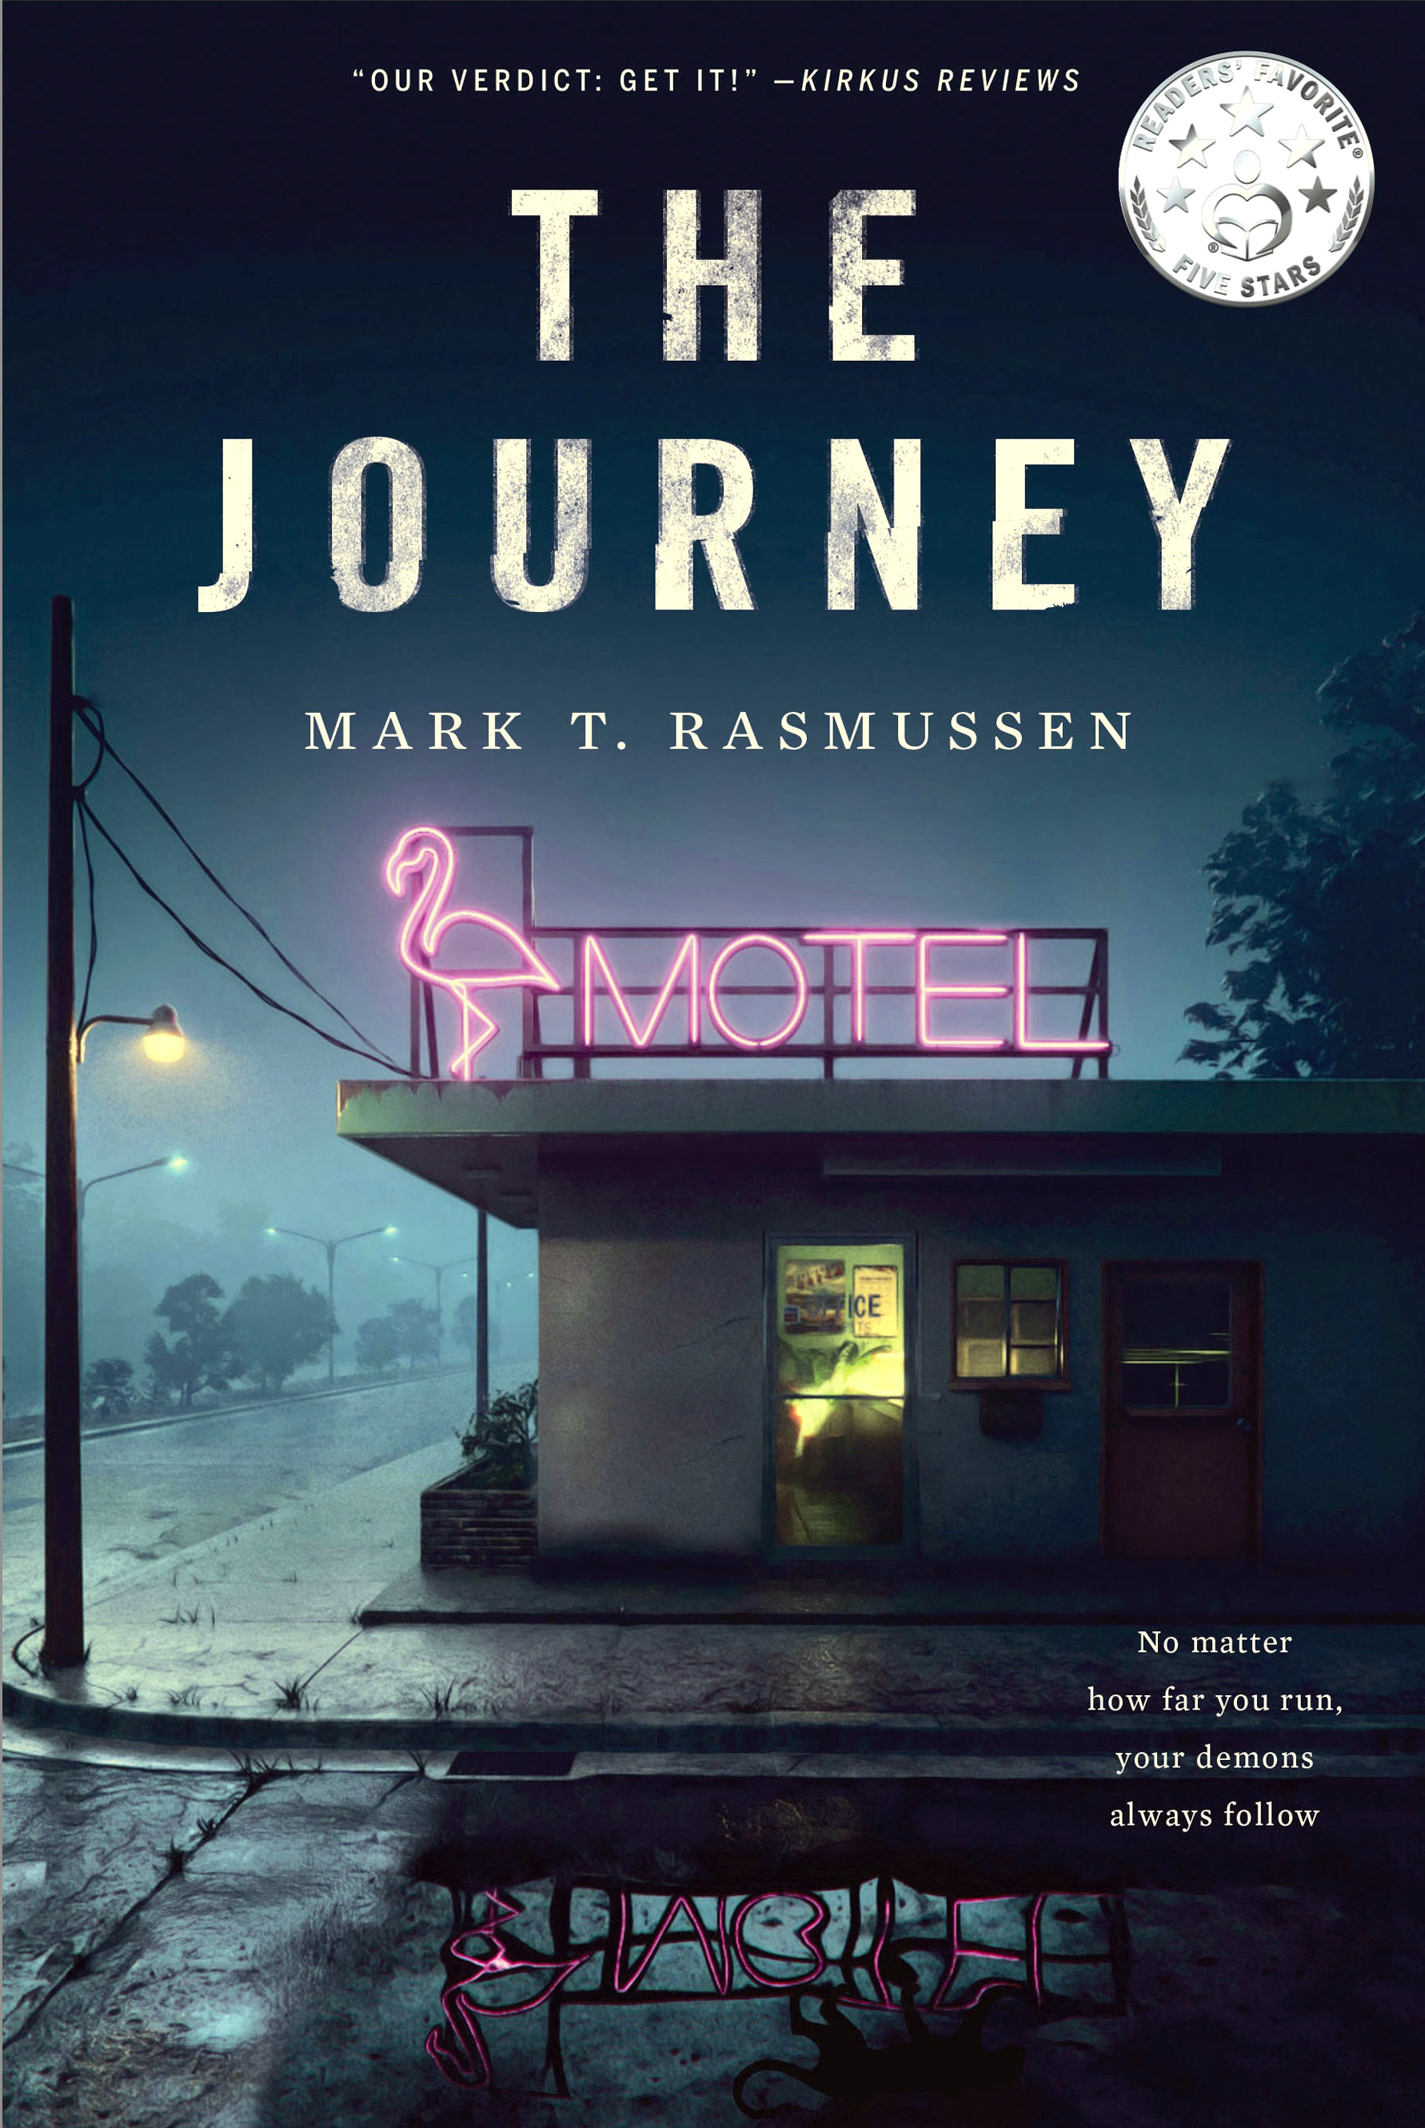
The Journey
By Mark T. Rasmussen

Publishing Date: October 10, 2022
Publisher: By the Pure Sea Books
Trade Paperback Edition
ISBN: 979-8-9867231-1-2 (paperback)
RRP: $14.99
Binding: 5x8 perfect paperback
Page count: 260 pages

PRESS CONTACT:
Mark T. Rasmussen
+1 310-880-4285
mark.rasmussen72@gmail.com
www.marktrasmussen.com

“The journey of a 1000 miles begins with a single step.” ~ Lao Tzu

Raiden, an emotionally troubled 40-something guy, is at a major turning point in his life. Rather than choose to face it head on, he undertakes an epic road trip adventure across North America, all with the aim of escaping the single most transformative event of his life – imminent fatherhood.

Searching for solutions in all the wrong places and faces, Raiden is forced to turn the mirror back on himself and shine the harsh light of reality not only on his quest, but into the very depths of his soul, in order to discover what it is he truly seeks.

While he does his best to find the answer, the impactful events he experiences along the way will reveal more about Raiden and his nature than the strange assortment of characters he meets on his overland odyssey.

Ultimately, The Journey is a story that no matter how far you run, your demons always follow.

REVIEWS:

- “As soon as I began reading, I couldn't put it down and read it in one sitting. Rasmussen has a talent for pulling the reader in from the very first page. I can't wait to see what he comes up with next. 5-stars!” – Amy Louise Hill, (Readers’ Favorite)
- “Stunning! One of the most provocative and engaging books I've read in years. The Journey takes you on a wild ride that becomes increasingly more riveting with every turn of the page. Rasmussen is a tour de force, weaving literary magic with beautiful music in a format unlike any other I’ve seen. A must read!” – Jennifer Juvenelle, author of Daughter of Belial
- “An ultimately upbeat novel with an engaging hero. Our verdict: Get it!” – Kirkus Reviews
- “It's a rollicking road adventure… and those seeking a character who undertakes a life-changing journey, will find The Journey epic on a psychological level that draws all ages.” – D. Donovan, Senior Reviewer, Midwest Book Review
- “Excellently penned and emotionally accomplished, in this dark, intense, and deeply interesting novel, Mark T. Rasmussen rewards readers with a fascinating tale of transformation. 5-stars!” – K.C. Finn (Readers’ Favorite)
- “An engaging, satisfying journey with a number of distinctive moments arising throughout, Rasmussen delivers an impactful story!” – BookLife

Cover images and other Author photos and contact information below

PRESS CONTACT:
Mark T. Rasmussen
+1 310-880-4285
mark.rasmussen72@gmail.com
www.marktrasmussen.com
SOCIAL MEDIA LINKS:
- Amazon (Author profile)
- Goodreads (Author profile)
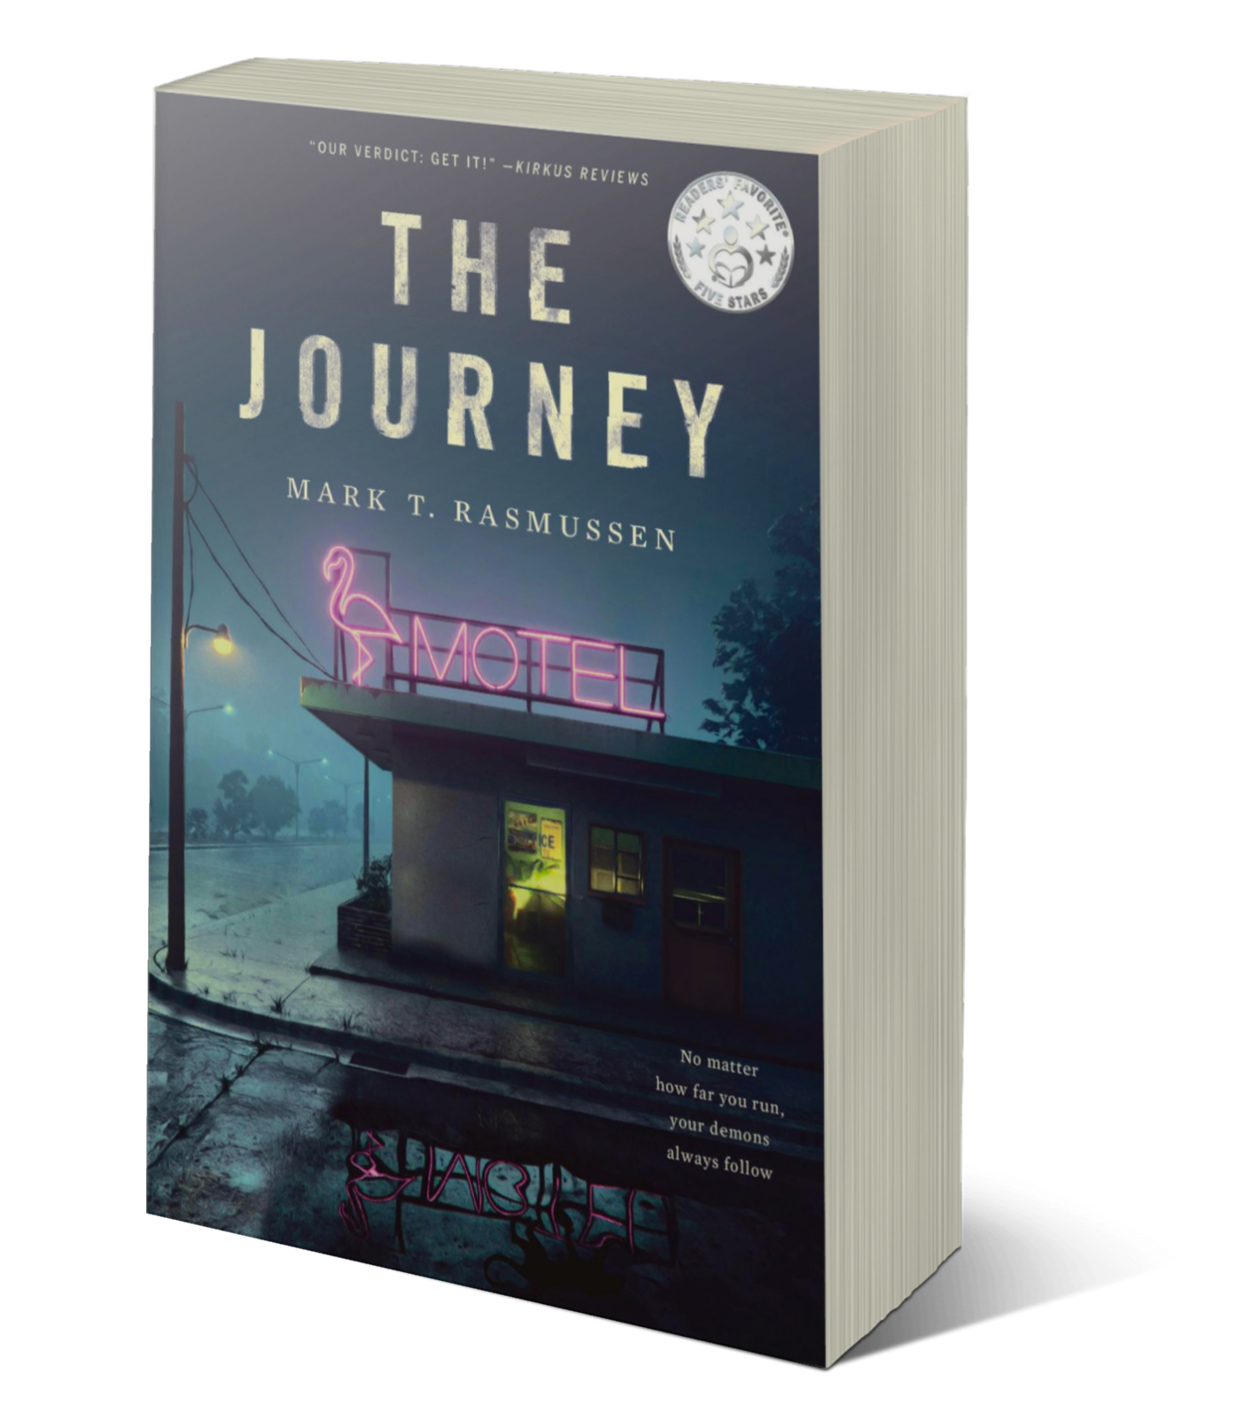
- LinkedIn (Mark T. Rasmussen)
- Website (Mark T. Rasmussen)

